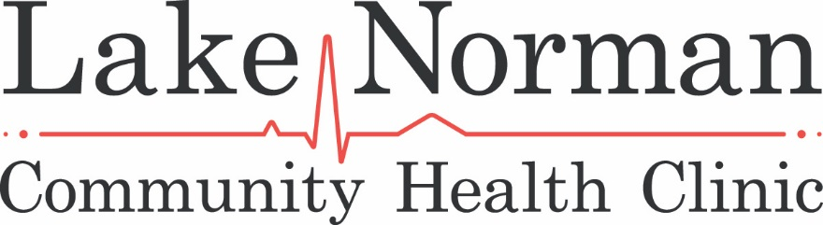

Dear Prospective Sponsor:

Lake Norman Community Health Clinic is the area’s oldest and largest clinic for the uninsured, serving 1,500 patients through 7,200 appointments annually. Our area is growing and thriving, but nearly 15% of those in the Lake Norman community are without coverage. They are family, friends, neighbors, students, employees and others who are not eligible for Medicaid, and who don’t earn enough to shop for marketplace coverage.

We would like to invite you to take part in Lake Norman Community Health Clinic’s 4th Annual fundraiser, Sunset and Sandals. This is a beach-themed event with dinner, dancing, silent and raffle auction. It’s a “Party with a Purpose” for those who believe no one should have to make tough, and even life-changing choices to delay or forego doctor visits because of costs.

As we commemorate our 20th Anniversary this year, we’re hopeful that you’ll consider supporting Sunset & Sandals in 2018. This year’s event will be held at the Peninsula Yacht Club on Saturday, June 2, 2018. The following sponsorships are being offered:

- Event Sponsor - $5000 - Includes 12 complimentary tickets; logo placement on all print, on-line marketing materials, and event signage; name recognition on media releases; website link on our website and online event registration; verbal recognition throughout the evening
- Platinum Level Sponsor - $3000 - Includes 8 complimentary tickets; logo placement on all print, on-line marketing materials, and event signage; name recognition on media releases; website link on our website and online event registration; verbal recognition throughout the evening
- Gold Level Sponsor - $1500 - Includes 6 complimentary tickets; name recognition on media releases; website link on our website and online event registration; verbal recognition during event
- Silver Level Sponsor - $750 - Includes 4 complimentary tickets; logo placement on signage at event and website link on our website and online event registration; verbal recognition during event
- Bronze Level Sponsor - $350 - Includes 2 complimentary tickets; logo placement or family name on signage at event; online event registration

Last year’s event was a huge success, but more importantly, the generosity of our sponsors ensured that our patients have access to compassionate, high-quality medical care. For more information, please visit www.lnchc.org or contact us at SunsetandSandals@lnchc.org . You may also contact us directly by email at lmcrae@lnchc.org. We thank you in advance for providing the support we need in building a healthier community.

