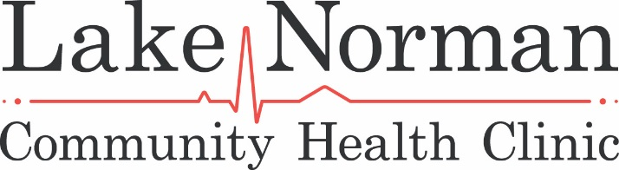

Sunset & Sandals Sponsorships

Event Sponsor*
logo placement on all print, on-line marketing materials, and event signage
name recognition on media releases
website link on LNCHC website and online event registration
verbal recognition throughout the evening
12 complimentary tickets
$5,000
*One event sponsorship will be sold
Platinum Level Sponsor
logo placement on all print, on-line marketing materials, and event signage
name recognition on media releases
website link on LNCHC website and online event registration
verbal recognition throughout the evening
8 complimentary tickets
$3,000
Gold Level Sponsor
name recognition on media releases
website link on LNCHC website and online event registration
verbal recognition during event
6 complimentary tickets
$1,500
Silver Level Sponsor
logo placement on signage at event
website link on LNCHC website and online event registration
verbal recognition during event
4 complimentary tickets;
$750
Bronze Level Sponsorship
logo placement or family name on signage at event
online event registration
2 complimentary tickets
$350

P.O. Box 2398 Huntersville, NC 28070 • (704) 316-6611 • www.lnchc.org

